common name: cranberry fruitworm

scientific name: *Acrobasis vaccinii* (Riley) (Lepidoptera: Pyralidae)

**Introduction – Distribution – Description** **– Economic Importance – Cultural Importance – Selected References**

**Introduction**

Cranberry fruitworms (*Acrobasis* *vaccinii* (Riley)) (**Figure 1**) are native to North America and have a host plant limited to the *Vaccinium* and *Gaylussacia* genera of plants in the family Ericaceae (Averill and Sylvia 1998). In the United States, *A. vaccinii* are a primary, direct pest of the large fruit American cranberry, (*Vaccinium macrocarpon* Aiton) and a significant pest of highbush blueberries, (*Vaccinium* spp. L.) (Fitzpatrick 2008). While cranberry fruitworm is a major pest in cranberry bogs in Massachusetts, populations have been recorded across North America (Averill and Sylvia 1998). The life history of cranberry fruitworms is closely synchronized with the fruit hosts on which they depend. Adult cranberry fruitworms emerge from hibernation (diapause) in the spring, mate, and lay eggs on their fruit hosts. Cranberry fruitworms are univoltine and only complete a single generation before overwintering as prepupa (Fitzpatrick 2008).

In the spring, adult females emerge from overwintering and lay their eggs on the developing fruit of their host plant. The neonate larvae quickly enter the fruit after hatching and feed exclusively inside the fruit (Fitzpatrick 2008). Once in the fruit, larvae feed on the pulp. As larvae grow larger, they move from berry to berry in a cluster, leaving behind frass caught in a silk net. High populations of these pests can destroy up to 50% of a cranberry crop (Mahr 2005, Simser 1994).

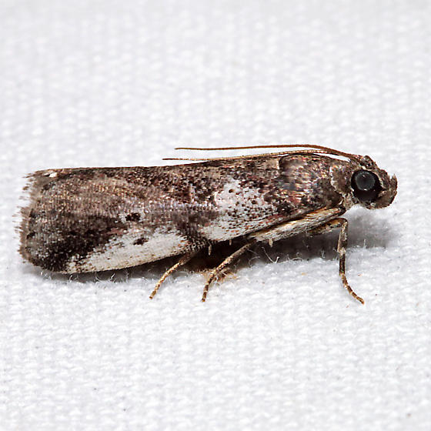

**Figure 1.** Adult cranberry fruitworm, *Acrabasis vaccinia* (Riley) (lateral view). Photograph by Ken Childs, www.bugguide.net*.*

**Distribution**

*Acrobasis vaccinii* moths are found in Quebec, Prince Edward Island, Nova Scotia, Maine, Massachusetts, Rhode Island, Connecticut, New York, New Jersey, North Carolina, Michigan, Wisconsin, Texas, and Washington (Averill and Sylvia 1998).

**Description**

TBA

**Economic Importance**

TBA

**Cultural Importance**

TBA

**Selected References**

Averill, A. L., and M. M. Sylvia. 1998. Cranberry Insects of the Northeast: A guide to identification biology and management. Department of Massachusetts at Amherst 46-51.

Fitzpatrick, S. M. 2009. Insect life histories in fruit, shoot and root environments of cranberry and blueberry. Acta Horticulture 810: 231-234.

Simser, D. 1995. Parasitism of cranberry fruitworm (*Acrobasis vaccinii*; Lepidoptera: Pyralidae) by endemic or released *Trichogramma pretiosum* (Hymenoptera: Trichogrammatidae). The Great Lakes Entomologist 4: 189-196.